2010-2011学年度潮阳实验学校青年教师基本功比赛教案
Name | 郑纯铮 |  | Subject | English | Time | November 23, 2010
Topic | Module 6 Unit 3 Using language HIV/AIDS: Are you at risk?
Teaching  Goals | Knowledge  and Ability | 1.Get the students familiar with some basic knowledge of the HIV/AIDS.  2.How to protect ourselves against HIV/AIDS  3.Improve the students’ ability of listening and speaking based on the topic
Teaching  Goals | Process and Method | 1. Pictures and videos  2. Listening and speaking activity  3. Group competition  4. Group work
Teaching  Goals | Emotional  Attitude and Values | 1. Make the students know that HIV/AIDS brings not only disease to people’s body but also suffering, such as misunderstanding, unfairness and so on.  2. Some correct ways can protect themselves and prevent diseases.  3. Have the students known the importance of life. Let them cherish life and care for others.
Teaching  key Points and difficulties | 1. Some background knowledge about HIV/AIDS.  2. In what ways the HIV virus spreads and how to stay safe.  3. Right attitudes towards HIV/AIDS (patients).
Teaching  Procedures  Teaching  Procedures  Teaching  Procedures | Step 1: Lead-in  1. Introduce the rules for this lesson  2. What will prevent us living a healthy life?  3..How much do you know about HIV/AIDS?.  Step 2: Reading aloud  In this part, ss are required to watch a video and read after the speaker in the video.  Passage 1: HIV is a virus. A virus is a very small living thing that causes disease. There are many different viruses, for example, the flu virus or the SARS virus. HIV weakens a person’s immune system; that is, the part of the body that fights disease. You can have HIV in your blood for a long time, but eventually HIV will damage your immune system so much that your body can no longer fight disease. This stage of the illness is called AIDS. If you develop AIDS, your chances of survival are very small.  - Watch the video for the first time, ask the students to listen and pay attention to the pronunciation.  - One minute for the ss to practice  - Play the listening material again and ask the ss to follow  - Read after the speaker.  - Ask some ss to practice.  Step 3: Ask and answer  Activity 1: Listen to a short passage. Then ask and answer.  Passage 2: HIV is spread through blood or the fluid that the body makes during sex. For a person to become infected, blood or sexual fluid that carries the virus, has to get inside the body through broken skin or by injection. One day scientists will find a cure for HIV/AIDS. Until that happens, you need to protect yourself. Here are some things you can do to make sure you stay safe.  Question 1. HIV病毒是如何传播的？  How can HIV spread? / In what way can HIV spread?  HIV is spread through blood or the fluid that the body makes during sex.  Question 2. 科学家们发现治愈艾滋病的方法了吗？  Have scientists found any cure for HIV/AIDS?  No, not yet.  - Play the listening material for the first time, ask the ss to ask the questions in English.  - Play it for the second time, ask the ss to answer the questions.  Activity 2:  1)Ask the questions in English. After asking, listen, take notes and then prepare for the following questions:  Passage 3: If you inject drugs, two advice you should remember. First, do not share your needle with anyone else. Because blood form another person can stay on or in the needle. If a person has HIV and you use the same needle, you could inject the virus into your own blood. Second, do not share anything else that a person has used while injecting drugs. Because blood could have spilt on it. If you have sex with a male or a female, remember to use a condom. This will prevent sexual fluid passing from one person to another.  Question 1: 在你注射药物时如何保护自己？(inject drugs)  How can we protect ourselves when injecting drugs?  Question 2: 性行为都是安全的吗？(have sex with sb)  Is it completely safe to have sex with others?  2)Since you have known some information about how to protect yourself against AIDS, listen again and answer the following questions.  Q1: How many ways should you pay attention to while injecting drugs?  A: There are two ways.  Q2: What are the ways to protect yourself while injecting drugs?  A: Do not share your needle or anything else that a person has used while injecting drugs.  Q3: How to protect yourself during having sex with others?  A: By using a condom.  Step 4. Discussing  Discuss the following pictures with your partners,and then answer the questions below and give your reasons.        P1:Can a person get HIV the P2:Do they look the same? P3: Only homosexuals get  first time they have sex? HIV/AIDS?  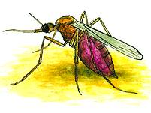  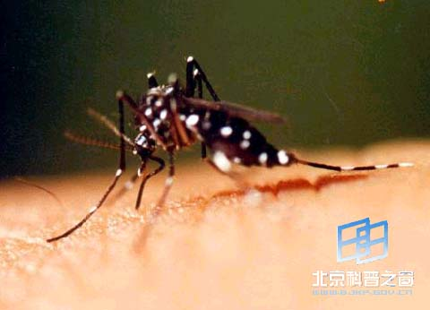  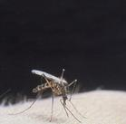  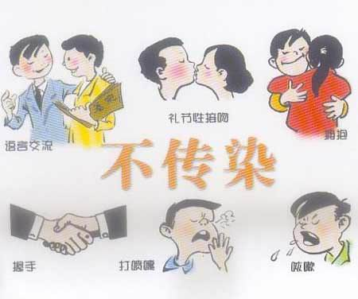  P4: Can HIV/AIDS be transmitted by…? P5:Can mosquitoes spread HIV/AIDS?  (communicating, kissing, hugging,  shaking hands, sneezing, coughing)  Step 5 Speaking  1.Is disease the only thing that AIDS patients suffer from?  2.How should we act towards people with HIV/ AIDS?Make a public-interest advertisement(公益广告) to tell others how they should act towards AIDS patients like Pu Cunxin.  Step 6 Summary  What have we learnt in this lesson?  1. Some background knowledge about HIV and AIDS  2. How to protect ourselves against HIV/ AIDS  3. Life is the most important thing in the world. We should cherish it.  Step 7 Assignment  Writing: My attitude towards AIDS (patients).  http://www.un.org/av/special/aids  http://www.boehringer-ingelheim.com/hiv/art/art_videos.htm

