教学活动设计
年级：五年级上册 单元名： What would you like to eat? 课时： 第4课时
- 任务目标：
单元任务目标 | 本课时任务目标 | 本环节任务目标
1 能熟练用核心句型表达自己最喜欢的食物及询问他人最喜欢吃什么，并进行回答。  2 能熟练运用核心句型询问他人想吃什么以及吃了什么，并进行回答。 | 1 能在板书的支持下， 说出核心词汇  2 尝试运用核心句型表达自己最喜欢的食物及询问他人最喜欢吃什么，并进行回答。  3 尝试运用核心句型询问他人想吃什么以及吃了什么，并进行回答。，并进行回答。 | 1 能在板书支持下，说出核心词汇  2 能听懂询问他人最喜欢吃什么和表达自己最喜欢的食物的核心句型，并尝试回答。
- 语言目标：
单元语言目标 | 本课时语言目标 | 本环节语言目标
词汇：fresh,healthy, sweet, delicious, hot, ice cream, tea, salad , sandwich, hamburger  句型：  What would you like to eat?  I’d like...  What’s your favourite food ?  I love...  We have... | 词汇：favourite, delicious, drink  句型：  What’s your favourite food ?  I love...  We have beef noodles and fish sandwiches today. | 词汇：favourite, delicious, drink  句型：  What’s your favourite food ?  I love...  We have beef noodles and fish sandwiches today.

- 本环节教学活动设计
环节 | 教学内容 | 教学方法 | 语言目标  （显性） | 体验目标  （隐性） | 教师话语 | 学生话语 | 课件 | 板书
从第__5___分钟开始  （总时长：_____分钟） | 活动1：  What’s Sarah’s favourite food?  活动2：  What’s Zhang Peng’s favourite food?  活动3：  Guess,What would they like to eat today?  Why?  活动4：  Make a tomorrow’s memu  (1)What’s your favourite food?  (2)What’s your mum’s favourite food?  (3)What’s your dad’s favourite food? | - Listen and say  - Try to answer  - Think and discuss  - Ask and answer | 词汇：favourite,  delicious  句型： What’s your favourite food ?  I love...  We have beef noodles and fish sandwiches today.  - 听懂句型  - 跟读句型  - 应答句型  - 仿说句型  - 描述词汇 | 1 推断能力  2 分析能力  3 逻辑整理能力 | T:Listen and answer, What’s Sarah’s favourite food?  T:Listen and answer, What’s Zhang Peng’s favourite food?  T:Look at Today’s Menu and guess ,What would they like to eat today?  Why?  T:How to make a tomorrow’s menu?  What needs to be considered?  (1)What’s your favourite food?  (2)What’s your mum’s favourite food?  (3)What’s your dad’s favourite food? | S1/S2:  beef noodles  S:fish  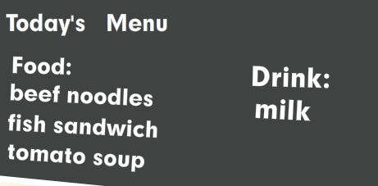  S1/S2:  Beef noodles and fish sandwiches  S1/S2:  Because Sarah loves beef noodles.  Zhang Peng loves fish.  S1/S2... | e  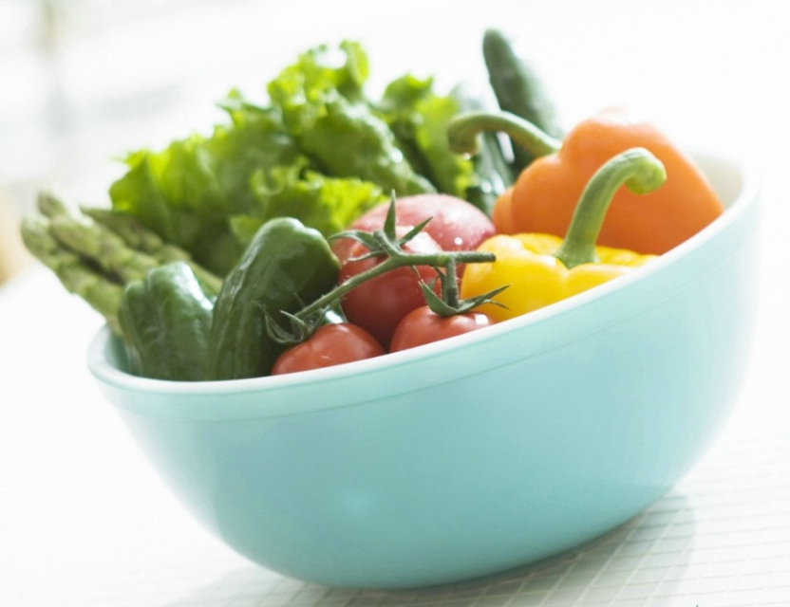 | What’s your favourite food ?  I love...  We have beef noodles and fish sandwiches today.  Menu:  Father:  Mother:  Me:
语言项目:
favourite, delicious.
What’s your favourite food ?
I love...
We have beef noodles and fish sandwiches today.

