英语研修作业
修改如下：
Unit 6 An old man tried to move the mountains.
Period1 Section A (1a-2c) 教案
一、Teaching goals（教学目标）
1. Enable the students to master news words and expressions.
2.Use the Past Tense to tell a story.
3. Enable the students to tell a story with unless ,as soon as ,so ...that...
二、Teaching key and difficult points（教学重难点）
1.How to improve the students ' listening and speaking skills .
2.Students are able to retell a story with the help of the key words and pictures .
三、Teaching procedure( 教学过程）
Step 1 自学指导（课本P41~P42）
- ________ n. 石头 2. ________adj. 虚弱的 3. _______v. 射击
- _______ v. 提醒 5、________n. 神 6.继续去做某事______________
7.从事 ______________ 8.将……拿走______________
9.派某人做某事___________ 10.一直做某事 _______________
Step 2 Leading in
以Guessing game 导入课堂，利用图片及音乐，激发学生学习兴趣，让学生参与到课堂。设计导入式问题如下：
Q: Do you know these traditional Chinese stories?
T: Let’s play a guessing game and know about these stories.
Look at the picture,and guess the name of the story.
(Chang’e Flies to the Moon、Magic Brush Ma Liang 、Yu Gong Moves a Mountain)
Step 3 Presentation
T:Yes ,they are really interesting stores ,let’s look at 1a.
1a 部分围绕4个故事，展示1a部分有关故事的插图，让学生预测要听到的内容，为1b部分做准备。
Step 4 Listening
T:Now,you will hear a great traditional Chinese story ,guess what it is.
Listen and check the facts you hear,which story Anna and WangMing are talking about .To learn “tell a story by listening .
听对话并摘录具体信息，以表格形式呈现。通过听来获取信息，同时也为后面1c部分所需要语言结构做铺垫，帮助学生复述环节，信息整理。
Step 5 Speaking
To encourage students to tell story through two questions .
How does the story begin? → What happened next?
SS discuss the questions in groups.
Step 6 Listening(2a)
T: So far, We have learned how to begin a story and the beginning of Yu Gong moves a mountain.
Do you know the rest of the story ?
让学生观看愚公移山视频，带着问题进入听中环节，导入到2a。
Step 7 Post-listening(2b) and reading
Ask students to fill in the blank. Then read the material together .
把听力部分内容，通过挖空，以短文填空形式呈现。
Step 8 Key points
- once upon a time = long, long ago 从前 常用于讲述故事开头的词语
e.g. Once upon a time, there lived three monks in a small temple.
- 连词
as soon as 一...就...
I will call you as soon as I come back.
so ...that ... 如此...以至于...
I was so scared that I could hardly think clearly .
unless 除非...如果不...
You won't pass the exam unless you work hard
- remind v.提醒，使想起
remind sb of/ about sth 使某人记起、想起...
remind sb that+从句 提醒某人
remind sb to do sth 提醒某人做某事
Step 9 Group work
Ss tell the story one by one with the pictures in 2a.
Retell the whole story with the help of key points and pictures.
Ask students to repeat the story sentence by sentence .
Step 9 Summary
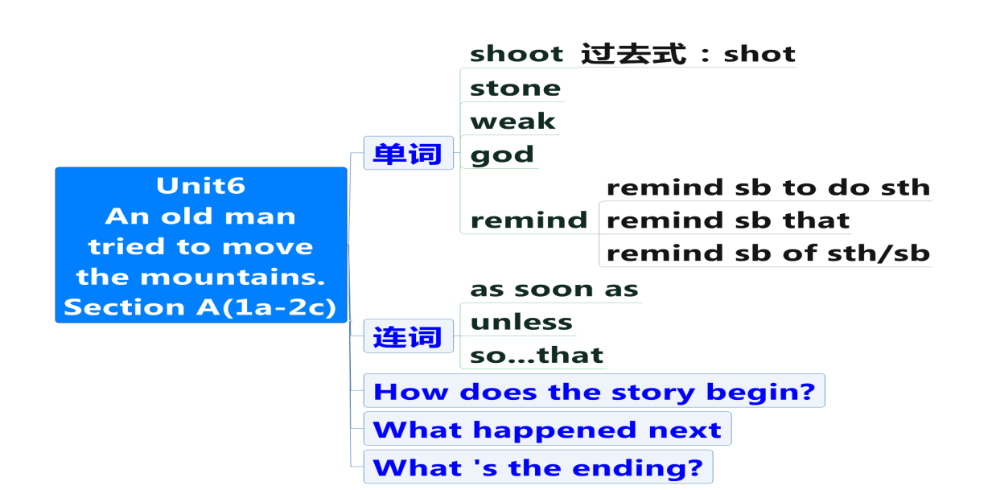

Step 10 Homework
1、Retell the story Yu Gong moves a mountain in English to your parents or classmates.
2、Share your favorite story with your friend.

