Book5 Unit5 First aid
First Aid for Burns 阅读课
教学目标：
- 阅读理解First Aid for Burns的内容。
- 进一步训练不同的阅读策略，把握文章的主旨大意，获取关键信息。
- 在适当的引导下完成课文的训练检测。
- 学习并掌握本课的重点词汇和短语。
教学重点：训练略读（skimming）、寻读（scanning）、精读（detailed reading）的阅读技巧。
教学难点：对课文的训练检测
方法指引：课前自主预习，课堂合作探究
Part1 课前查阅：
- Brainstorming: What words can you think of when you talk about accidents？
Bleeding(流血) ; _____; _____; _____; _____; _____; _____; _____
- What first aid can you give in such situations？
Part2 课前自主预习
(组长利用晨读最后5分钟利用听写的方式检查组员的单词背写并打分上交。)
- 重点单词

1．____________['æŋkl] n．踝(关节)
2．____________[skIn] n. 皮；皮肤
3．____________['ɔːɡən] n.器官
4．_________['bæriə] n. 屏障；障碍(物)
5．____________['lIkwId] n. 液体
6．________['simptəm] n. 症状；征兆
7．______________['sizəz] n．(pl)剪刀
9．________________['pres] v.按压
10．_________[pɔː(r)] vt.& vi.倒；灌；
11．________[swel] vt.& vi. (使)膨胀；12．_________[ə'plai] vt.& vi.涂；申请
13．__________['vaitəl] adj.至关重要的
14．_________['kɒmpleks] adj.复杂的
15．_______[triːt] vt.& vi.治疗；对待
16．_________['pɔizn] vt.使中毒n.毒药

- 重点短语

1．_____________急救
2．_____________生病
3．_______________反复；多次
4．________________榨出；挤出
5．___________________找到
6．__________________在适当的位置
7．____________________若干；许多
8．______________有影响；

Part 3 教学过程

Step1 Warming up
Get students to see some pictures of accidents and have a guess to lead in the topic.

Step1 Pre-reading
Get students to have a first aid quiz to prepare for the reading passage.
〖小组讨论 合作探究〗
Step3 Reading
Ⅰ Skimming（略读）:
(把握文章文体和主旨大意) 学法指导：
快速浏览文章首尾段(有小标题的看小标题)，初定文章主旨，兼顾各个段落主题句，确定答案。跳过细节和不重要的描述或例子。

Task1: Choose the type of writing of the passage.
A. narration (记叙文) B. argumentation （议论文）
C. exposition（说明文） D. novel（小说）
Task 2: Match main idea with each part.(浏览小标题)
- Causes of burns
B.The functions of skin
C.First aid treatment
D.Characteristics of burns
E.Types of burns
Part 1
Part 2
Part 3
Part 4
Part 5

Ⅱ Scanning（寻读）:

(寻找所需细节信息) 学法指导：
通过寻读法(scanning)，用题干中的关键词在文中搜索，迅速确定相关词句或信息点所在的位置，缩小阅读范围。题干中可用来在文中搜索的关键词可能是专有名词、时间名词、形容词、数词、动词或动词短语以及这些词的同义表达等。

Task3：Choose the best answers according to the passage.

1.Which of the following is NOT the function of the skin according to the text?
A．It protects you against disease，poisons and the sun’s harmful rays.
B．It helps the heart beat.
C．It can keep you warm or cool.
D．It prevents your body from losing water and gives the sense of touch.
2.In the text，burns are called first，second，third degree according to the ___ of the skin burned.
A．layer B．function C．type D．area
3.Which is not one of the characteristics of second degree burns?
A. Extremely painful B. Turn while when pressed
C. Rough, red and swollen D. Watery surface
4.When someone is burned, what should be done first?
A. Dry the burned area gently B. Remove clothing
C. Cool burns immediately D. Cover thr burned area with a bandage

Ⅲ Detailed Reading：

学法指导：
认真的阅读,体会里面的深层意思,挖掘主旨,或英语中句子的意思。

Task4: What are the causes of burns?

Task5: Label （分类）these pictures first,second, and third degree burns and match（连线） types with characteristics.

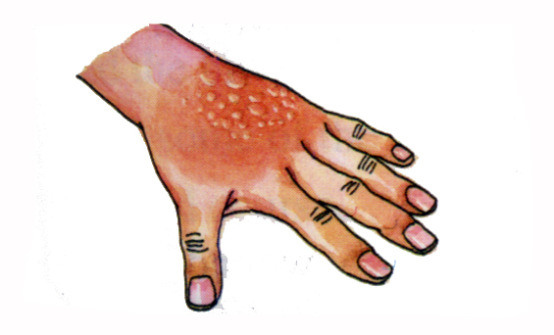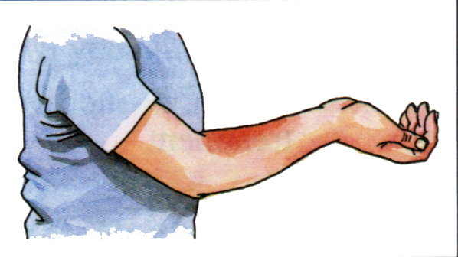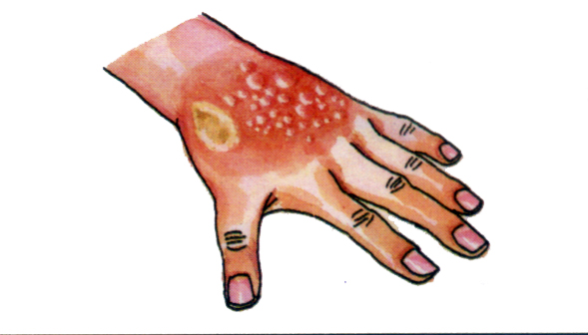

A.Tissue under them often can be seen.
B.Mildly swollen
C.Extremely painful

Task 5 : First aid treatment step by step
Put the following 6 steps about treatment for burns in order.a.Dry the burned area gently.
b.Cool the burns with cool water.
c. Cover the burned area with a dry clean bandage.
d.Remove clothing near the burn.
e.Place cool, clean wet cloths on the burns.
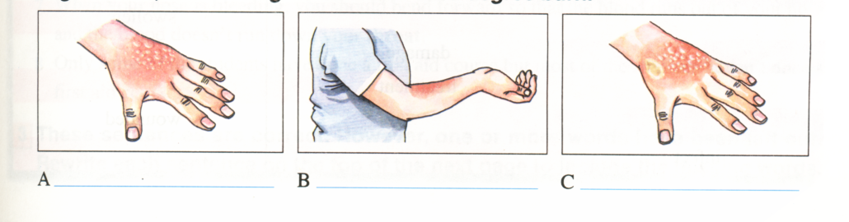
f.Get the victim to the hospital
Part 4 训练检测
THE GAME TIME ：Emergency situation(模拟急救)
Group work:(Pick out a card from No.1-No.10)

How do you perform first aid in these situations ?
1.One group perform how to give first aid
2.The other groups guess what kind of accident is it according to their performance of first aid.
(Rule： If your guessing is right,you can get 2 points for your group;if not,the performing group will get 3 points .)

Part 5 A summary of this lesson

Part 6 Homework（课外阅读提升）
1. Memorize the key words and phrases in this unit.
2. Finish the reading comprehension by using the reading skills learned in this class.
Low-Cost Gifts for Mother's Day
(2013 全国I卷 D )

Gift No. I
Offer to be your mother's health friend. Promise to be there for any and all doctor's visits whether a disease or a regular medical check-up. Most mothers always say "no need," another set of eyes and ears is always a good idea at a doctor's visit. The best part ? This one is free.
Gift No. 2
Help your mother organize all of her medical records, which include the test results and medical information. Put them all in one place. Be sure to make a list of all of her medicines and what times she takes them. "Having all this information in one place could end up saving your mother's life," Dr. Marie Savard said.
Gift No. 3
Enough sleep is connected to general health conditions. "Buy your mother cotton sheets and comfortable pillows to encourage better sleep," Savard said. "We know that good sleep is very important to our health."
Gift No. 4
Some gift companies such as Presents for Purpose allow you to pay it forward this Mother's Day by picking gifts in which 10 percent of the price you pay goes to a charity (慈善机构) Gift givers can choose from a wide variety of useful but inexpensive things -many of which are "green" - and then choose a meaningful charity from a list. When your mother gets the gift, she will be told that she has helped the chosen charity.
48. What are you advised to do for your mother at doctor's visits?
A. Take notes. B. Be with her. C. Buy medicine. D. Give her gifts.
49. Where can you find a gift idea to improve your mother’s sleep?
A. In Gift No. 1. B. In Gift No. 2. C. In Gift No. 3. D. In Gift No. 4.
50. Buying gifts from Presents for Purpose allows mothers to________
A. enjoy good sleep B. be well-organized
C. bet extra support D. give others help

